

User Manual


- Introduction 1
1.1 Why C-SMART 1
- Getting Started 1
  - Prerequisites & Installation Instructions 1
  - User Access Considerations 1
  - Accessing the systems 2
  - Accessing the clusters 3
  - Cluster Movement 4

Table of Contents

1. Introduction
C-SMART: A small desktop based application which will reside on the Basis Administrator's machine and will help in identifying the impacted systems during a network outage scenario. The application comes with built in intelligence to pick up the server details and check for available services from locally stored excel files.


As the server details and the service details are maintained in the excel file, addition / removal of any servers and/or services is easily possible.

1.1 Why C-SMART?

In the event of a network outage the amount of time taken to identify impacted SAP systems is extremely high. There are approximately 2400 application servers that are being used in the SAP environment. Manual checking for all these servers takes around 400 minutes for 30 administrators and is extremely tedious. Current set of tools that are available are all server based and provide information when the server is available. The turnaround time for recovery is thereby impacted when the server is unavailable.

Current scenario:

- Number of Basis resources needed during outage = 30

- Number of Servers to be checked = 2400 (including all the production / project rail systems)

- Time taken for manual checking of each system = 5 minutes

- Total time spent for checking all systems = 2400*5 / 30 = 400 minutes (close to 7 hours)

Using C-SMART:

- Number of Basis resources needed during outage = 4 (considering each resource runs the check for one single stack)

- Number of Servers to be checked = 2400

- Time taken for execution of C-SMART = 1-2 minutes / stack (depending on the network speed)

- Total time saved for identifying the impacted systems = 400 - 2 = 398 minutes (close to 6.75 hours of efforts)

2. Getting Started

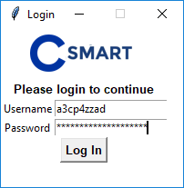
2.1 Prerequisites & Installation Instructions

- The windows application is built using programming language Python, so Python 3.7.2 needs to be installed on the machine.

2. Perform the advanced install and choose all options:

2.1 python -m pip install --upgrade pip --user
2.2 pip install openpyxl --user
2.3 pip install paramiko –user

Ref: Link to download Python: https://www.python.org/downloads/

2.2 User Access Considerations

Basis administrator needs to log in using AD user id and

password.

2.3 Accessing the system

- After clicking the login button from the picture shown above, it will display the list of tasks as shown below.

- After selecting System View task, it will show the environment and we can select multiple systems at the same time to get the information for the selected environment.

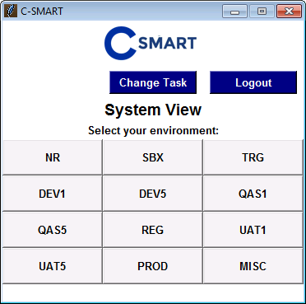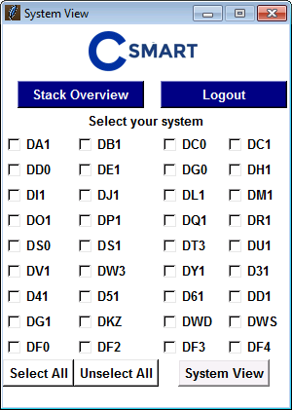

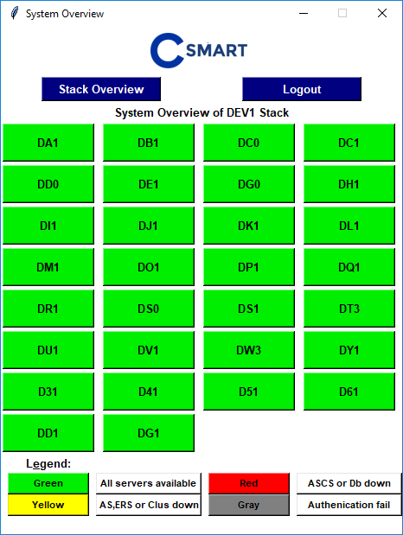
- After this selection, it will display the systems and notify the system status as per the following color convention

Green: All servers available

Yellow: AS, ERS or Cluster down
Red: ASCS or DB down
Gray: Authentication failure

This information comes from the excel sheet using Openpyxl.

- After selecting the particular system, it will display the SAP system details

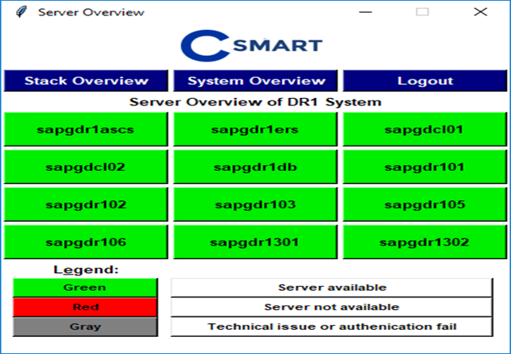

2.4 Accessing the clusters

To check the status of the cluster select the particular stack from the stack overview screen and click on ClusterView. It will notify as per following color convention:

Green: Server available

Red: Server not available
Gray: Technical issue or authentication failure
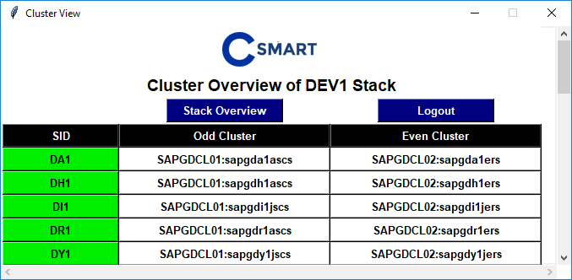
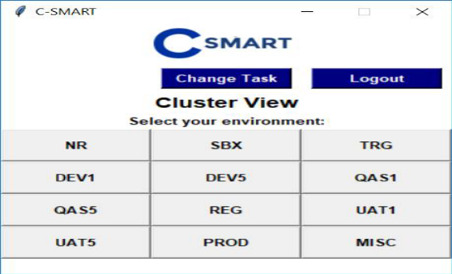

2.5 Cluster Movement
1. To rebalance or move the clusters during maintenance activity select the particular stack from the Stack Overview screen.
2. Select the environment for which cluster needs to be moved.
3. After selecting the particular environment, it will display the services running on the individual clusters. To rebalance, select the rebalance tab from the below screen. And, to move the cluster from even to odd and vice versa select the move to even/odd tab from the cluster overview screen.

